NAME: WINSTON CHU

memories of james ruse….
One of my vivid memories would be those ag. pracs that we used to have with Ms Roberts such as feeding those chooks and growing snow peas. I remembered Mr Wearne used to tell us quite frequently when we got stuck with 4U maths, “derive it from first principle” and I’ve found it not only usual in maths but also in other fields such as architecture. I also remembered that we used to hang around that lonely tree near the auditorium with our shirts untucked and Mr Canty used to warn us to tuck them in but now, tucking out shirts is becoming the new fashion!

what i've been doing since school…
After year 12, I went to study architecture at Sydney University. In 1996, I won a travelling scholarship to study at the Academy of Fine Arts in Vienna and I had a great opportunity to travel to different cities in Europe such as, Paris, Prague, Rome and Munich etc. Worked briefly in Vienna and it was tempted to stay in Europe however, as the budget was drying up, it was time to head back to Sydney to finish of the architecture degree. Finally, I graduated in 1997 and worked in Sydney for several large firms such as Peddle Thorp Architects and in Dec 2000, I got married to my lovely wife, Connie. Shortly after our wedding, it was time to travel again and this time was China. For about 1.5 years, I worked with an Australian architectural firm called Kann Finch Architects in Beijing as a design architect on numerous large projects around China. Recently, I have decided to come back to Sydney to establish my own architectural practice and importantly, to renew contact with old friends and family here.

my hopes for the future….
I hope we could maintain our contact for many years to come. At this stage, my wife and I are too busy with travelling and our careers so no baby yet. I hope to set up a successful architectural practice to test out some of my own architectural philosophy and one day, become a reasonably respectable architect.

PHOTO
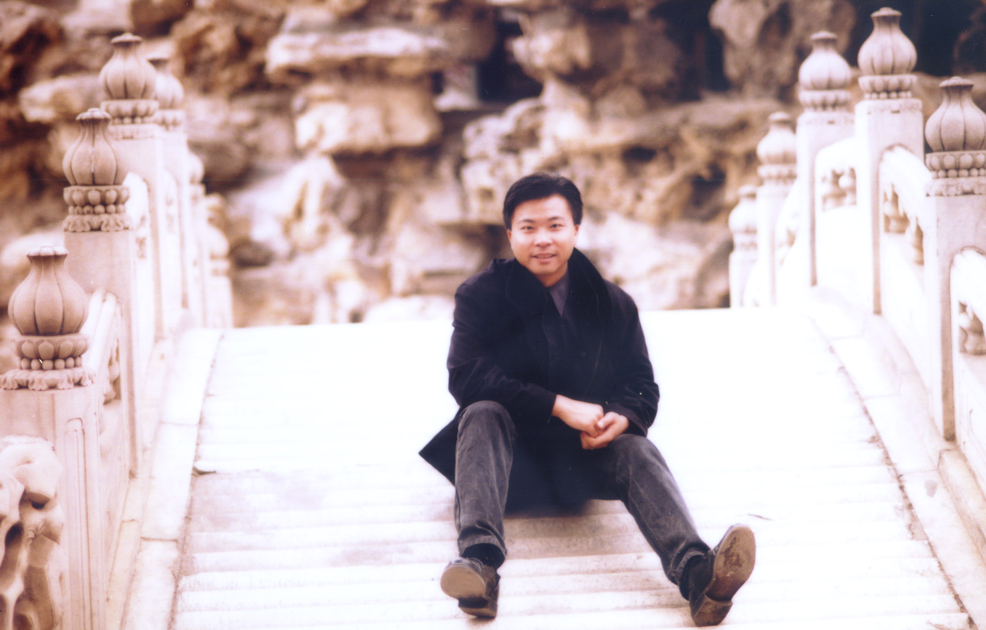

quote: NEVER BURN DOWN YOUR BRIDGES

