Rebecca Shead (nee Lovell)

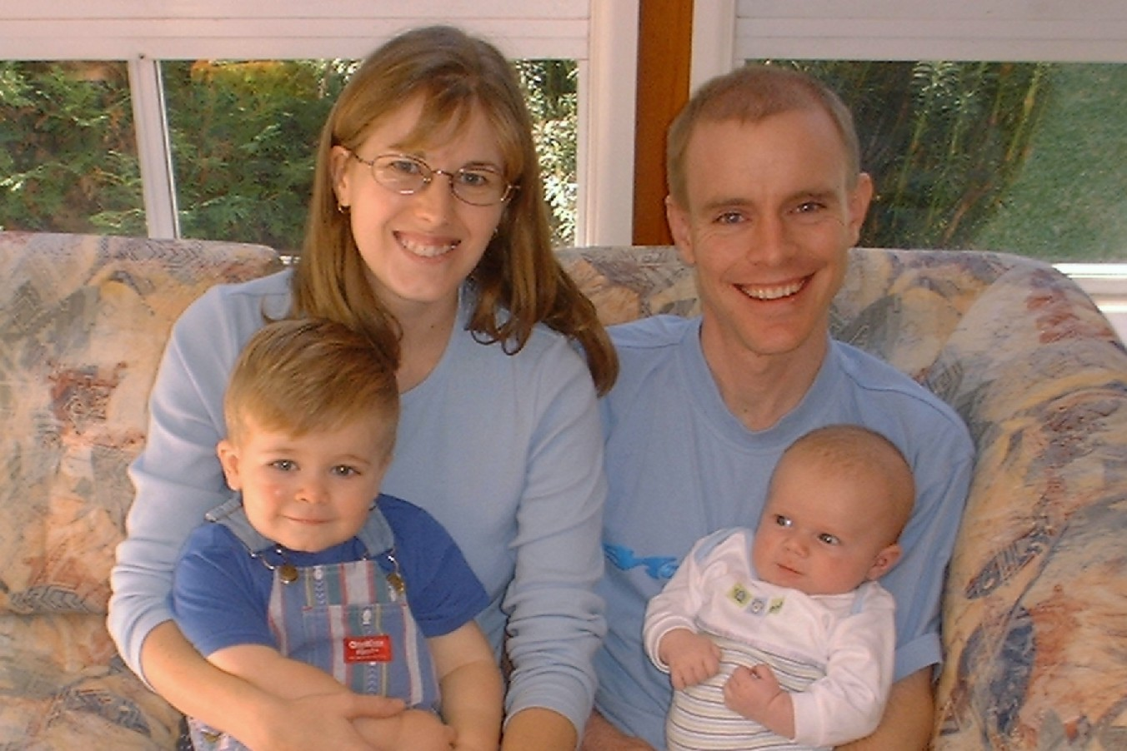

After Year 12, I spent 5 years at Sydney Uni doing Dentistry. I married Stephen at the end of my fourth year. I worked for 3 years at 3 different private dental practices, which I generally enjoyed. I have also done (part time) a diploma course at Moore Theological College, while Stephen was doing a four year degree there. I am now a full-time mum, and I'm not sure yet whether I'll go back to work in the near future. We have two boys, Benjamin (28/10/2000) and Lachlan (28/2/2002).

Stephen is currently doing a PhD in Biblical Studies at Sydney Uni, and will be the part-time assistant minister at Fairfield Anglican Church for the next two years. We hope to go to Santiago, Chile at the beginning of 2006, where Stephen will lecture at a Bible College which is starting up next year. So in the next few years we are planning to learn some Spanish! We are also hoping to survive the sleepless nights, constant nappies and occasional tantrums that come with two cute little boys.

