Matthew Webster

Things I Shouldn’t Remember
Jeeze, I thought most kids grew out of handball in Primary School, but not us! It made a resurgence in Year 11 and 12. I remember I didn’t get out at all for one entire recess...

In Japanese, we were encouraged to get to class early by being awarded gold stars. The funny thing is, it actually worked.

Sport
Unexpectedly, I found myself graduated from a Science Degree and working 9-5 only 3 years after starting uni. Somehow, with less free time (but more money), I decided to take up triathlons.

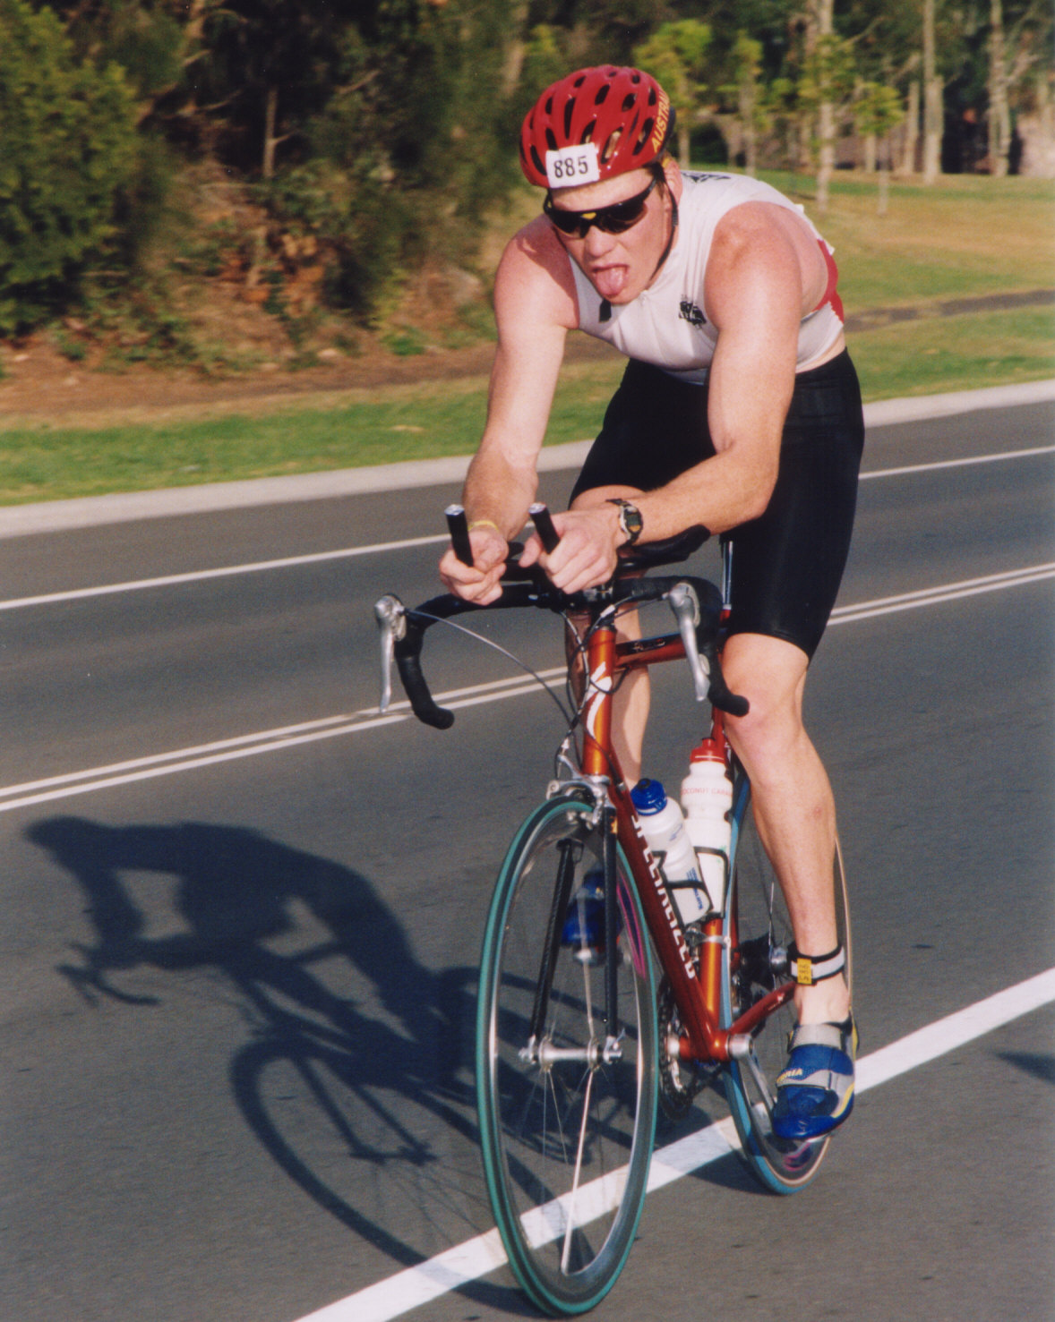
Seven years later I’m still out there training most days, enjoying the fitness and friends it brings me, as well as the travel opportunities it brings (Edmonton 2001, Maui 2002, plus many more places locally). My current goal is the Forster Ironman next year, a 3.8km swim, 180km ride and 42.2km run.

Japanese
Back in 1987, a real keen bean (me) reckoned Japanese was the language to learn. Given a fantastic opportunity (in the form of a Japanese teacher), I resolved to learn this bloody language. I soon realised this was not going to happen at school (although I thoroughly enjoyed the PE staff room gossip that made up the bulk of our lessons), and vowed to visit Japan for a year.

This took place 5 years after leaving school, and began with me cleaning toilets and making beds in a hotel with an outlook over the Olympic Slalom course, but soon changed as the snow melted and I found myself in a small city teaching primary school age kids English. I never once thought during those days of being forced to study “The Chant of Jimmy Blacksmith” and the like, that one day I would find myself teaching English (albeit ESL).

Later, I even found myself performing a few wedding ceremonies (as I looked the part).
Since returning, I found work at a Japanese company (Canon), so I haven’t forgotten as much Japanese as I should have.

