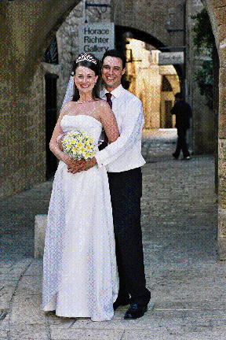
Lucy and Oren, Israel, September 18, 2002
Wow, it’s hard to believe it’s been ten years! The last ten years have seen many changes for me - here’s my last ten years in a nutshell…

After school, I studied Agricultural Economics at Sydney Uni with Samantha Ridler. In 1997, I started work as a graduate trainee in Agribusiness Research at the Commonwealth Bank. In my third year at the bank (in the Investor Relations division by then), I started a Master of Commerce (Marketing) degree as I wanted to steer my career in that direction.

In January 2000, I went on exchange to Cornell University in Ithaca, New York. I had a fantastic time both personally (meeting my husband, Oren) and professionally. Then I worked in Boston as a Public Relations Coordinator for a computer graphics start-up for a year.

In April 2001, Oren proposed to me on City Island (just outside of Manhattan) and we moved in together in July 2001 in New York. I started working for a small technology PR agency and Oren started working for an investment bank.

I am currently freelancing in marketing (branding, PR and events) for the American Australian Association and the Australian Aboriginal Fine Art Gallery of New York. Oren and I celebrated our Jewish wedding in Israel in September and look forward to our civil wedding in Sydney in December.

L u c y H a r e l (C u r l e w i s)

