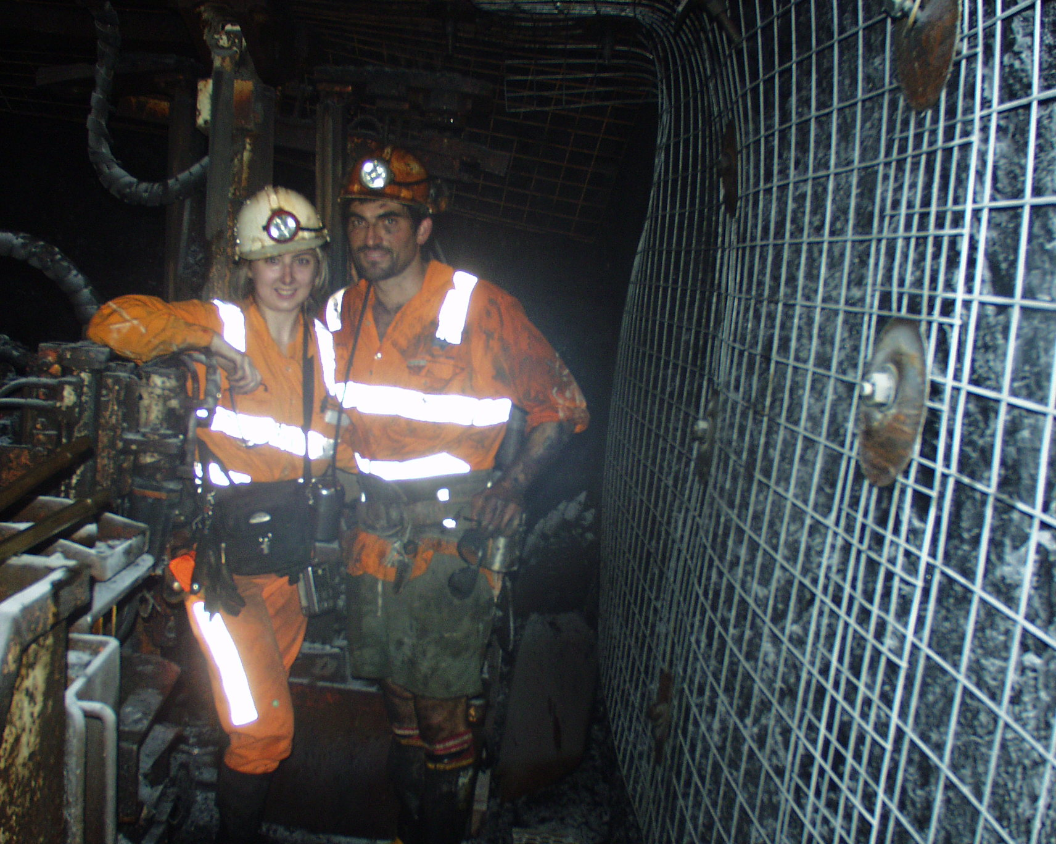
Justine Drew Calleja and John Calleja captured underground for the first time!!

Dear Rusians,
Long time no see. I will be thinking about you all on the day of the reunion from atop a snow covered Canadian mountain. My husband of one year, John, and I will be scraping through earning a mere $400/wk each but living our dream. We'll be skiing to and from work where John will be doing deliveries around the ski village and I will be working on ski patrol rescuing mad teenagers with broken legs. At night I will be relaxing in a Jacuzzi then skiing to a nearby restaurant to play violin for the diners.
Over the past 10 years I have worked myself into the ground. I got a scholarship for mining engineering and ended up with 1st Class Honours. I then started the upward battle for a successful career working 60-100hrs per week in a coal mine in Lithgow. My hard work paid off as I received numerous promotions and substantial pay increases over the next few years. John works in the mining industry as a crew leader underground. We struggled for two years to find work in the same area so we could live together and achieved our goal in 99 at a mine in Central Queensland near Emerald. We had a fabulous time living in a little mining village where we knew everyone and spent all our free time socialising. However being so far from home and family drew us back to Sydney when the job opportunity came up. We moved back to the Hunter Valley and spent pretty much all of our energy working. I was doing ridiculous hours and John was working 12 hour shifts underground. We finally got married on October 18 2001 in the Historic Little Hartley Village in the Blue Mountains and had a wonderful holiday in the Maldives. Then it was back to reality. I had been getting very run down during the year. After we got back from our holiday I got worse and worse. I was exhausted all the time, dizzy, headaches, nauseous and fainting. I had a really incompetent boss who had no idea of what I was doing in my job or how it needed to be done. He decided to assert his authority and reprioritise my work - meaning I would need to work 16 hour days instead of 12s. I was in no state to do it. So I tried for a week before I made a really expensive and highly public mistake as a result of exhaustion. That was my breaking point, so i handed in my resignation. My boss didn't accept it but sent me home to have a good think. I spent the next two weeks sleeping and the next 6 months trying to get back to health. During that time the company tried to fire me and make things as difficult as possible. John recieved similar treatment from the same company due to any injury he'd had underground. We both said, "What's the point?"
I have almost destroyed myself to spend my life making money and getting promotions. John has given up his free time and risked his health for money. What have we got to show for it?
NOTHING
Well we do have financial freedom and security but what is the benefit of that if I had killed myself trying to achieve it? We could die tomorrow without having LIVED.
What I have learned since school is that deferring happiness for a higher goal is not wise or admirable, its a waste of life. There is no mysterious reason why I was put on this earth that I must chase down with all my energy. The purpose of life is to live. Simple really. So thats what I vow to do from now on.
PS. Any Rusian Skiers are welcome to come and stay with John and I at Big White Ski Resort in BC. Its free accommodation and probably cheaper than going to Perisher. Plus a nice cool escape from the blistering summer heat.
Contact: Julie Drew, 02 95191315, 102 Angel St Newtown NSW 2042
Email: juzjohn@hotmail.com
Cell Phone: Canada, 514 296 4788
Name: Justine Drew now Justine Drew Calleja

