NAME: JENNY HARVEY

memories of james ruse….

Wagging double maths on Friday afternoons down on the farm… Waterpolo games against Homebush boys (uggh)… the end of term movies… laughing with friends and not really having a care in the world.

what i've been doing since school…

After finishing Law at UTS and doing some obligatory travelling in the UK I started a three month contract with Baulkham Hills Shire Council doing among other things, compulsory acquisitions (think… "The Castle"). Almost five years later I'm still there after a few more trips to various continents whenever funds allowed. I finally got admitted as a solicitor in October 2000.

Now I'm back at UTS again completing my MBA and have acquired a mortgage on a nice little flat in Rozelle. No marriage or kids to go with it yet, but maybe in the next ten years…

my hopes for the future….

To work to live not live to work… to complete the Noosa triathlon next year… see some more of the world, perhaps cycling in Europe and visiting family & friends.

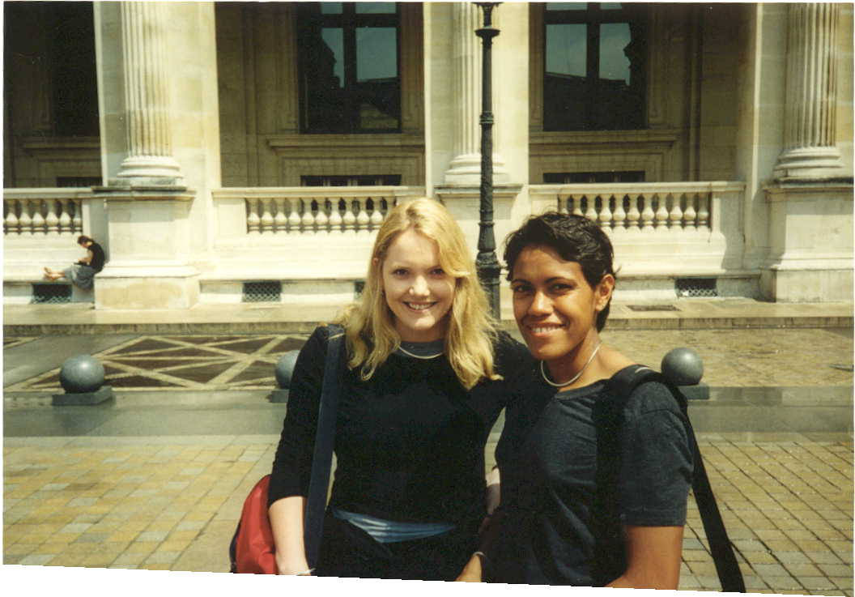

With my training partner Cath in Paris - ok, ok
we were just lining up for the same museum!

