NAME:
Jennifer Cooper

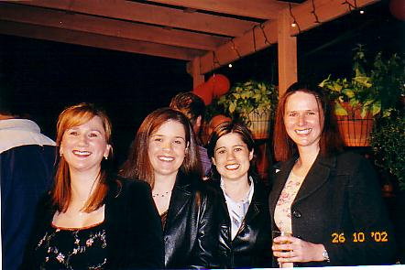
MEMORIES OF SCHOOL:
The dumb jokes that the boys played on each other, which they're STILL laughing about ten years later.

WHAT I'VE BEEN DOING:
The boring stuff - finished Bachelor of Town Planning at end of 1997…worked at Blacktown City Council as a Town Planner from 1995 to 2000, enjoying a nine day fortnight, a Council car and free petrol…started a 'proper' job in 2000 as a Town Planner with AT Cocks Consulting, now known as Urbis as we got tired of kids ringing us in the school holidays and asking us what kind of Cocks we consulted…promoted to Senior Town Planner in Sept 2001 and currently working on major retail, commercial and industrial developments and providing property advice for corporate clients.

Other stuff - done some travelling, though close to home and not as much as I'd like - bits and pieces around Asia, as well as a few big camping trips through eastern, southern and central Australia…became a proud auntie of Chloe in July but no plans for one of my own any time soon…living in Balmain and currently enjoying single life and the 17 pubs on the peninsula.

FUTURE PLANS / DREAMS:
Work-wise, to become Associate Director at Urbis in the immediate future, with long term goal to be an equity Partner… also, to stop talking about it and actually take some decent time off work and go and see the world…to buy my own place - hopefully, within reasonable proximity of the city and slightly bigger than a shoebox…and, while I know it sounds trite, to be happy and content with life.

CONTACT DETAILS:
jcooper@urbis.com.au

My Year 10 formal dress still fits (just). We recently had a formal cocktail night, which was an excuse to get out our old bridesmaid and formal dresses. My friend's mullet wig in the above photo wasn't nearly as good as the real mullet sported by my Year 10 formal partner in 1990 - you know who you are.

