NAME: Helen troup (soon to be O’brien)

memories of james ruse….
Fantastic friends, homework, cows, nerds… loved it all!!!

what i've been doing since school…
BSc (Nutrition & Human Movment) MSc (Nutrition & Dietetics)
Manager Health & Fitness – Solar Springs Health Retreat
Sales Rep- Sports Medicine
Moved to Melbourne
GP Rep – Novartis Pharmaceuticals
Hospital Account Manager – Novartis Pharmaceuticals (Psychiatry)

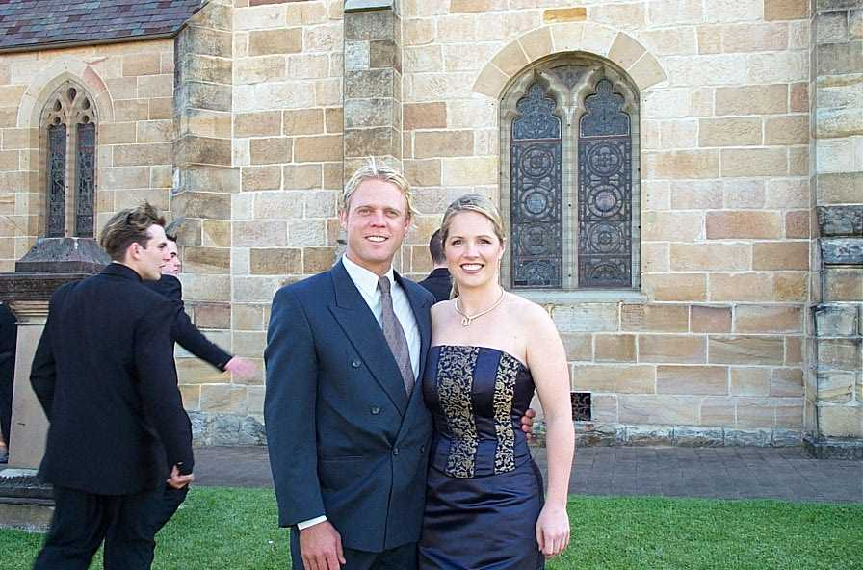
my hopes for the future….
I’m getting married in March 2003 to a talented landscaper named Mark so I hope for a wonderfully happy marriage and a healthy family…. Oh, and world peace.

(insert photo/optional)

quote:
People in Melbourne don’t realise that when you say you went to James Ruse it’s another way of telling people you’re actually intelligent!

