NAME:AdRian cory

memories of james ruse….
- YEAR 11 DRAMA PRODUCTION – SET CREW (AWESOME)
- mY PUNCH UP WITH mISS aNDERSON IN THE LIBRARY
- tHINKING I KNEW EVERYTHING (& NOW REALISING I DIDN’T)
- tHE BUS TO PARRA STATION
- GOOD FRIENDS WHO I DON’T SEE ENOUGH OF NOW

what i've been doing since school…
bUGGERISING AROUND. WORKED IN HOSPITALITY FOR AGES. BOUGHT AND SOLD A café IN NORTH SYDNEY WITH MY THEN FIANCE. WENT BACK TO STUDYING ENGINEERING FOR THE SECOND TIME A FEW YEARS AGO. (WILL BE DOING IT FOR THE REST OF MY NATURAL lIFE!).
TRAVELLED A FAIR BIT.
GOT MARRIED IN 2001.

my hopes for the future….

TO BE HAPPY. MAYBE HAVE A FAMILY AT SOME STAGE.

(insert photo/optional)
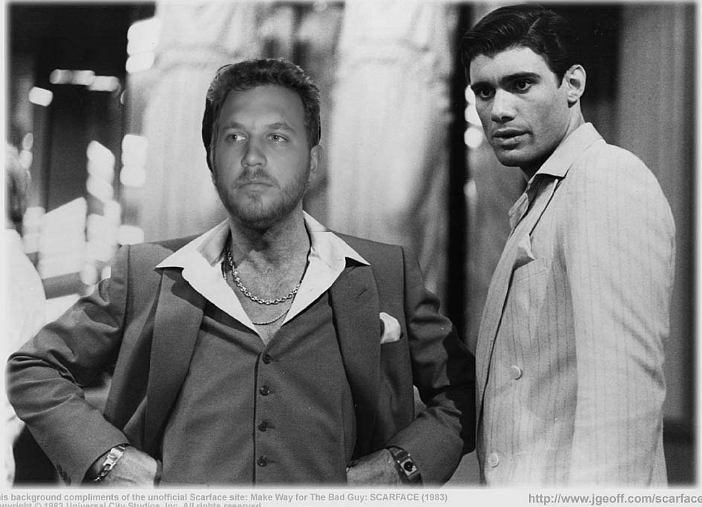

quote: “mEASURE tWICE, cUT ONCE” – eARL mORRIS – A BLOODY GOOD PIECE OF ADVICE!

